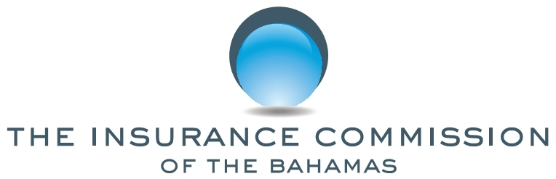

PUBLIC NOTICE

No. 6 of 2019 2 September, 2019

This NOTICE is issued by the Insurance Commission of The Bahamas (“the Commission”) pursuant to sections 8, 128(c) and 229 of the Insurance Act, Ch. 347 (2009 Consolidated Statute Laws).

The general public is hereby notified that pursuant to sections 8 and 128(c) of the Act, the registration of Star General Insurance Agents & Brokers Limited has been cancelled. Star General Insurance Agents & Brokers (Grand Bahama) Limited, has changed its name to Star General Insurance Agents & Brokers (Bahamas) Limited, as per their request.

The general public is further notified that pursuant to section 119 of the Act, the company has been granted a certificate of registration under its new name, Star General Insurance Agents & Brokers (Bahamas) Limited as an insurance agent and broker. The company is permitted to conduct general insurance business in The Bahamas.

All policies under Star General Insurance Agents & Brokers Limited and Star General Insurance Agents & Brokers (Grand Bahama) Limited will be administered by Star General Insurance Agents & Brokers (Bahamas) Limited.

Any questions in this regard may be directed to the Superintendent of Insurance, in writing, at P. O. Box N-4844, Nassau, Bahamas or delivered to the Insurance Commission, Poinciana House, 31 East Bay Street, Nassau, Bahamas. The Commission may also be contacted via email at info@icb.gov.bs

Michele C. E. Fields
Superintendent of Insurance

