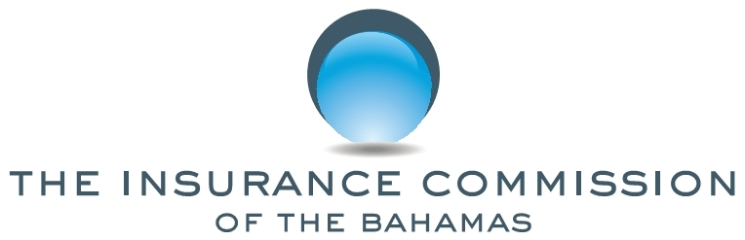

PUBLIC NOTICE

No. 7 of 2019 16th September, 2019

This NOTICE is issued by the Insurance Commission of The Bahamas (the Commission) pursuant to sections 119 and 229 of the Insurance Act, Ch. 347 (2009 Consolidated Statute Laws).

The general public is hereby notified that the Insurance intermediaries listed below have been registered as insurance adjusters to carry on insurance business in The Bahamas.

The general public is further advised that all registrants are issued with a certificate of registration by the Commission, bearing the Commission’s logo, signature of the Superintendent of Insurance, and name of the company, registration number and date. The list of registered insurance intermediaries is available at www.icb.gov.bs.

The solicitation of insurance business by unregistered adjusters is a criminal offence and is subject to fines under the Insurance Act.

Any questions in this regard may be directed to the Superintendent of Insurance, in writing, at P.O. Box N-4844, Nassau, Bahamas or delivered to the Insurance Commission, Poinciana House, 31 East Bay Street, Nassau, Bahamas. The Commission may also be contacted via email at info@icb.gov.bs.
.

INSURANCE INTERMEDIARY | CATEGORY | REG. NO.
Fitzgerald Claims Consultants (Caribbean) Ltd | Independent Adjuster | 53017
Beverley William George Fitzgerald | Individual Adjuster | 54013

Michele C. E. Fields
Superintendent of Insurance

