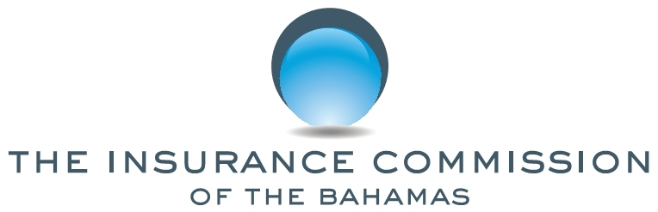

PUBLIC NOTICE

No. 8 of 2019 16 September, 2019

This NOTICE is issued by the Insurance Commission of The Bahamas (the Commission) pursuant to sections 28 and 229 of the Insurance Act, Ch. 347 (2009 Consolidated Statute Laws).

The general public is hereby notified that pursuant to sections 8 and 229 of the Act, Co-operative Assurance Limited has been registered as an insurance company to carry on insurance business in The Bahamas.

The general public is further advised that all registrants are issued with a certificate of registration by the Commission, bearing the Commission’s logo, signature of the Superintendent of Insurance, class of insurance business, address and name of the company, registration number and date. The list of registered insurance companies and insurance intermediaries will be available at www.icb.gov.bs.

The solicitation of insurance business by unlicensed companies is a criminal offence and is subject to fines under the Insurance Act.

Any questions in this regard may be directed to the Superintendent of Insurance, in writing, at P.O. Box N-4844, Nassau, Bahamas or delivered to the Insurance Commission, Poinciana House, 31 East Bay Street Nassau, Bahamas. The Commission may also be contacted via email at info@icb.gov.bs.

Michele C. E. Fields
Superintendent of Insurance

